**Financial Management**

Financial management for IT services is a service delivery element of the ITIL framework. The aim of this process is to give accurate and cost effective management of IT assets and resources used in providing IT services. Financial management helps to plan and recover the cost expended on the IT services which will be agreed on the SLA’s.

As per the ITIL (Information Technology Infrastructure Library) principals, the financial management in service strategy should aim to include the following things for any new product development:

1. It should be accountable for all the funds for the IT services required for the new product development.
2. Assign the cost to the services which are delivered to the customer using the IT services.
3. All the changes in the IT services should be monitored by the decision making team and explain in detail the IT investments and cost analysis to the organization.

As rightly said by Powell, M., & Ansic, D. (1997) the key concepts of financial management should be:

1. **Budgeting:** It involves the prediction of cost and revenue to the company. The primary function of the budgeting is to understand the demand for the services and the related cost which the company incurs to fulfill the demand.
2. **Accounting:** To monitor the flow of money a particular IT organization spends is called accounting. It’s very important to determine the cost for each customer, service and activities of the organization.
3. **Charging:** The activities involved in the process to bill the customer is called charging.
4. **Cost Models**: There are two different cost models:

1.cost to customer

2.cost to service.

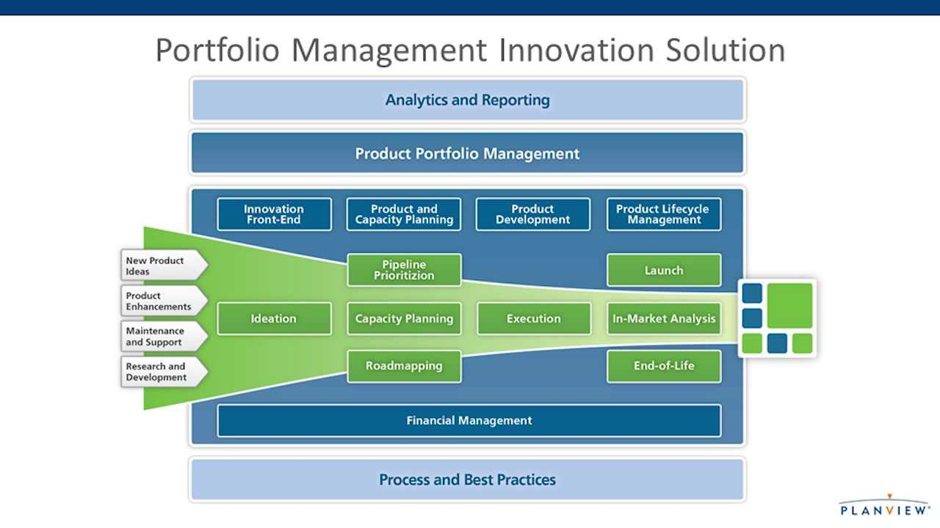

*Fig1 ITIL v3* *Product development solution: Financial management*

Referring to fig 1, which was disclosed by Planview (Organization), we can confidently plan investments for new product success if we refer to the process and best practices mentioned above. They explain how to perform the Top-Down and Bottom-Up product financial planning. According to Planview, we can perform the strategic financial planning by distributing the budget by priorities of the project. They explain that by centralizing all the budget information, the management is well informed about the available budget to spend on the product or any service launch in the market.

They also explain in detail a very important factor which every organization should do on a regular basis i.e. Tracking the total cost of development**:** It is very essential to stay on top of all the factors that are affecting the financial costs to the organization to mitigate the issues before they are uncontrollable. We have to measure and compare project finances at each stage to make sure if it needs more financing or investment to be successful when the product or services are launched. By referring mainly to Planview’s financial procedures and O'Reilly, C. A. we try to rule down our financial management strategies for our new product launch.

Considering the above standard principles of ITIL, Planview and referring to many peer review articles, we try to layout the financial management system for our Whealth app. As this is new product in the market we try to allocate the cost by finding the cost objects such as marketing department, IT services, customer relationship, advertising, R&D and so on. We tend to achieve the market share by focusing on the short term and long term goals.

According to O'Reilly, C. A. (1982) a company who launches new product in the market should mainly focus on investing 20% of the budget on the marketing and advertising to introduce the product and make the customers aware of the new service. In this scenario, by knowing our target customers we can have a clear picture as in where to invest the money and how to achieve the market place for our product.

To survive the tough competition in the initial days we tend to spend 10% of our budget to give many offers and deals to the customer to initialize the service. After we lay out the strategies to capture the market, our major focus of cost allocation will be on the IT services, over 50% of the money will be invested in the IT services. As this a software product, and we need to concentrate more on the Hardware and software part of this product. IT services will cover the hardware, software, database, servers, systems and manpower to handle the process.

We initially focus only on one city so the cost incurred to set up the IT services and the cost of manpower are low. If the response of the product is good and if we generate a good revenue, our next goal will be to expand our services to other cities and then we have to invest more on the IT services as we will require more manpower, software and hardware to fulfill the demand. Out of the remaining 20% of the budget, 10% will be spend towards the miscellaneous costs of the company and the rest 10% will be kept as liquidity to handle any incident and problem management issues.

We will continuously monitor the flow of our money and make the required changes once the process is in flow. We will cut down the cost in the areas in which the investments are not necessary at this point of time and focus on the revenue generating areas. Once the pilot process is completed we will start charging the customers according to the standard market price to generate profit.

As finance is included in all the areas of a product development we will follow the standard ITIL principles to manage the flow of money by fulfilling the goals of the organization taking care of all the areas such as budgeting, accounting, charging and cost models.

**References**

Powell, M., & Ansic, D. (1997). Gender differences in risk behaviour in financial decision-making: An experimental analysis. *Journal of economic psychology*, *18*(6), 605-628.

O'Reilly, C. A. (1982). Variations in decision makers' use of information sources: The impact of quality and accessibility of information. *Academy of Management journal*, *25*(4), 756-771.

Merchant, K. A. (1981). The design of the corporate budgeting system: influences on managerial behavior and performance. *Accounting Review*, 813-829.

Flamholtz, E. G. (1983). Accounting, budgeting and control systems in their organizational context: theoretical and empirical perspectives. *Accounting, organizations and society*, *8*(2), 153-169.

Walker, M., & Choudhury, N. (1987). Agency Theory and Management Accountin. *Arnold, JA, R. Scapens and D. Cooper, Management Accounting: Expanding the horizons, London: Chartered Institute of Management Accountants*, 61-112.

Shehab, E. M., & Abdalla, H. S. (2001). Manufacturing cost modelling for concurrent product development. *Robotics and Computer-Integrated Manufacturing*, *17*(4), 341-353.

Rehman, S., & Guenov, M. D. (1998). A methodology for modelling manufacturing costs at conceptual design. *Computers & Industrial Engineering*, *35*(3), 623-626.

**Other References**

[**http://www.managementstudyguide.com/financial-management.htm#**](http://www.managementstudyguide.com/financial-management.htm)

<http://www.planview.com/solutions/product-development/financial-management-pd/>

https://www.linkedin.com/pulse/20140825024259-11499331-the-5-recommended-steps-for-completing-a-financial-justification-for-product-launch